**Lab 26**

**Configuring Endpoint and access the s3 bucket**

**Scenario: We have required to access s3 service without internet access from private subnet.**

Create one windows instance with Public subnet. We need to install command line interface tool in that instance.

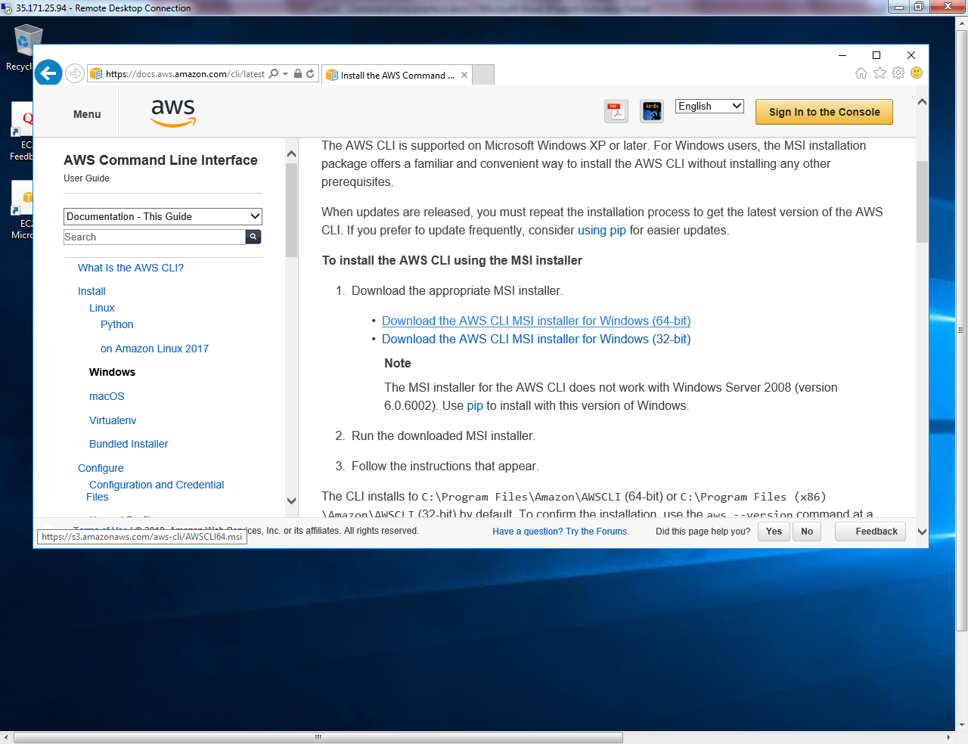

Download the package in public instance.

Go to services and click “VPC”.

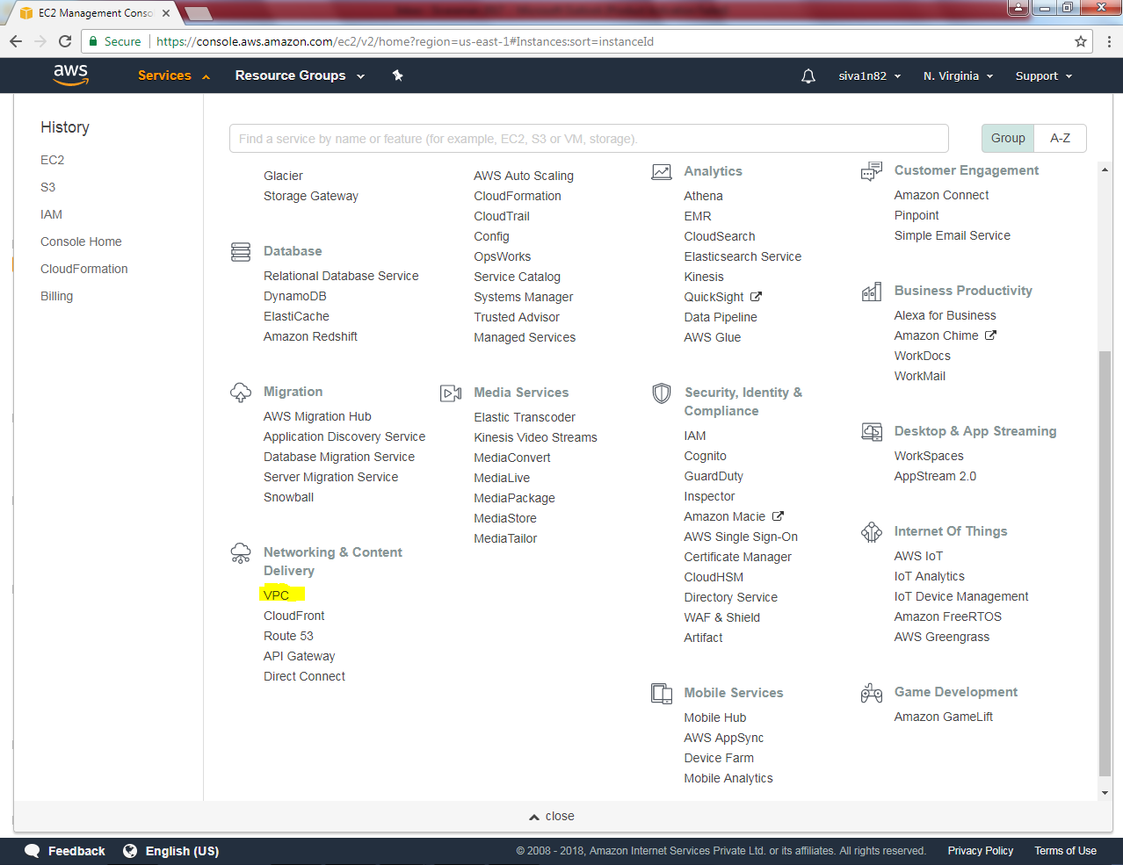

Click Endpoints and click “Crete Endpoint”.

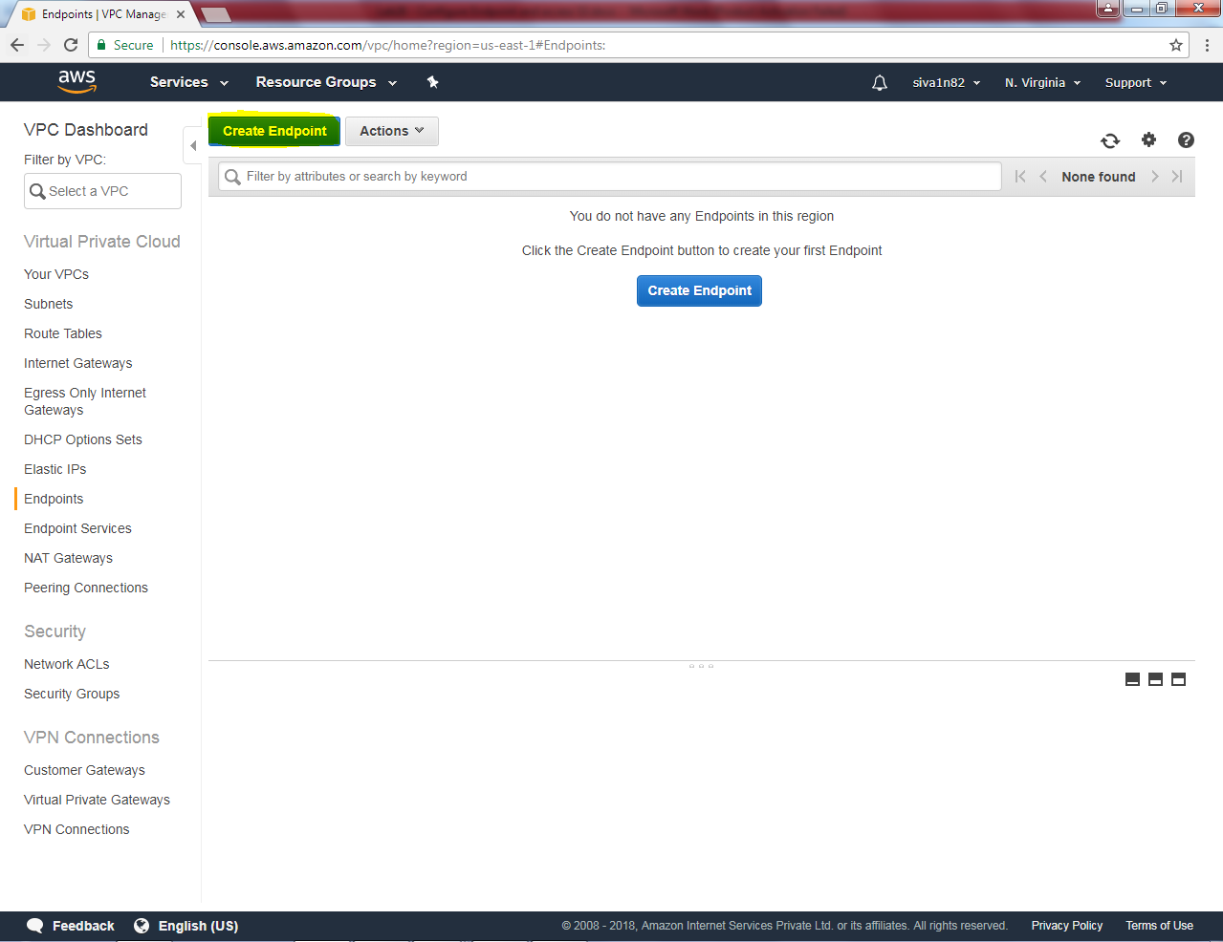

Select S3.

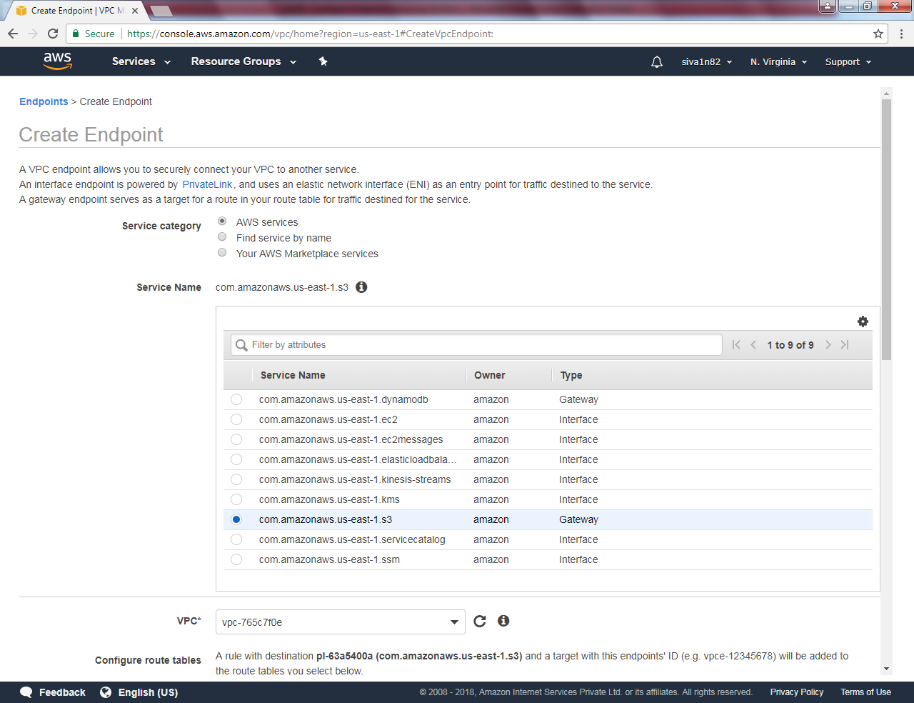

Select VPC and select sanbound VPC’s subnet.

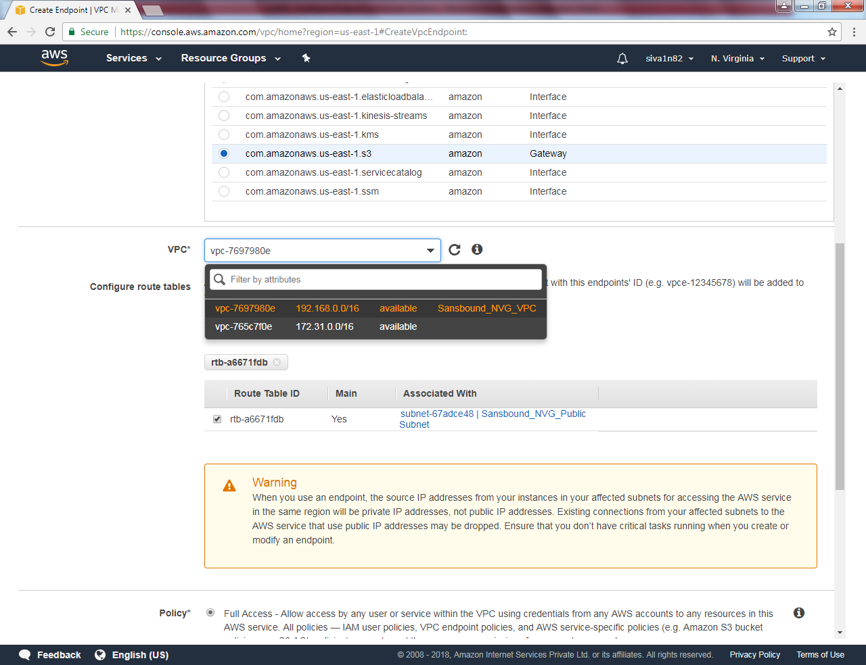

Create “Create Endpoint”

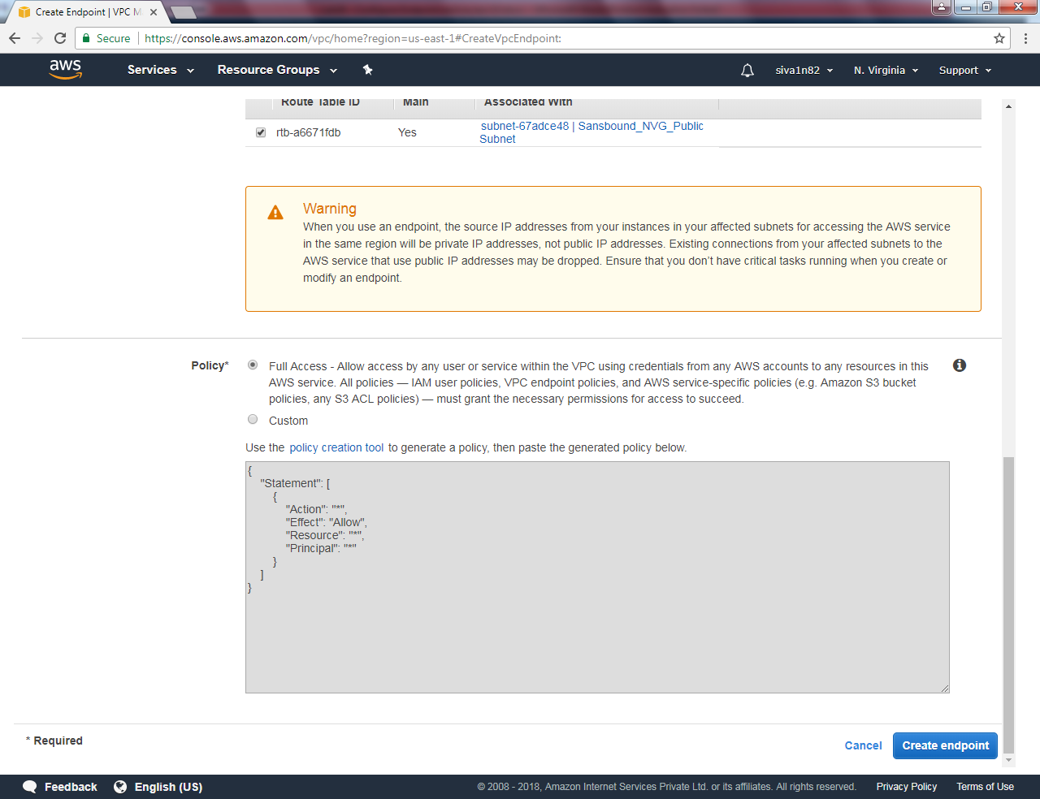

Endpoint has been successfully created.

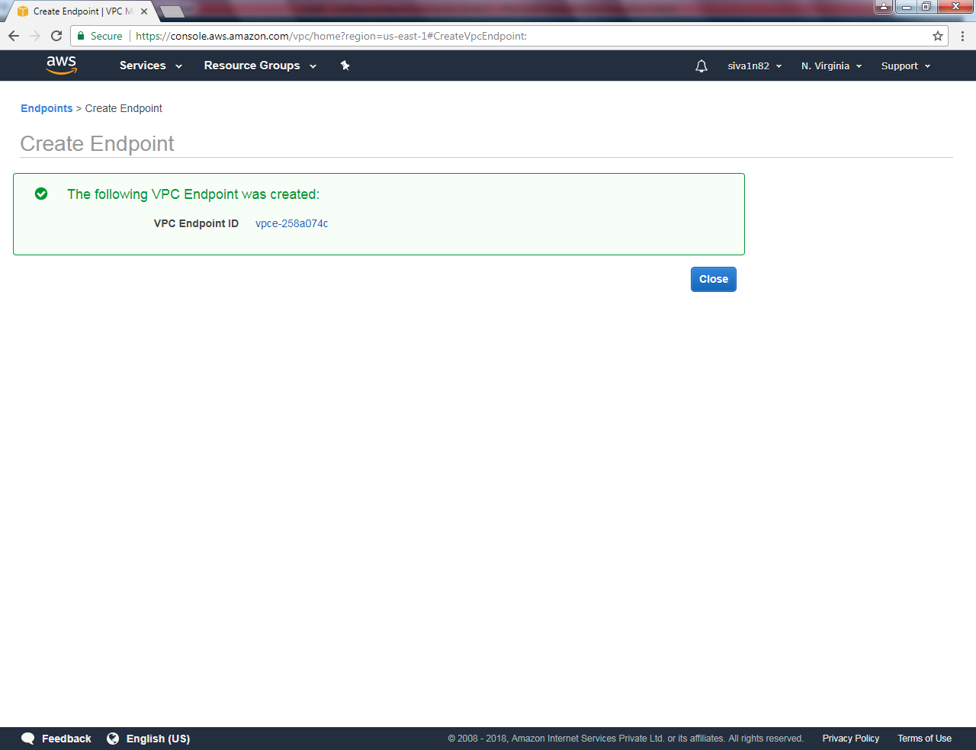

Endpoint is now available.

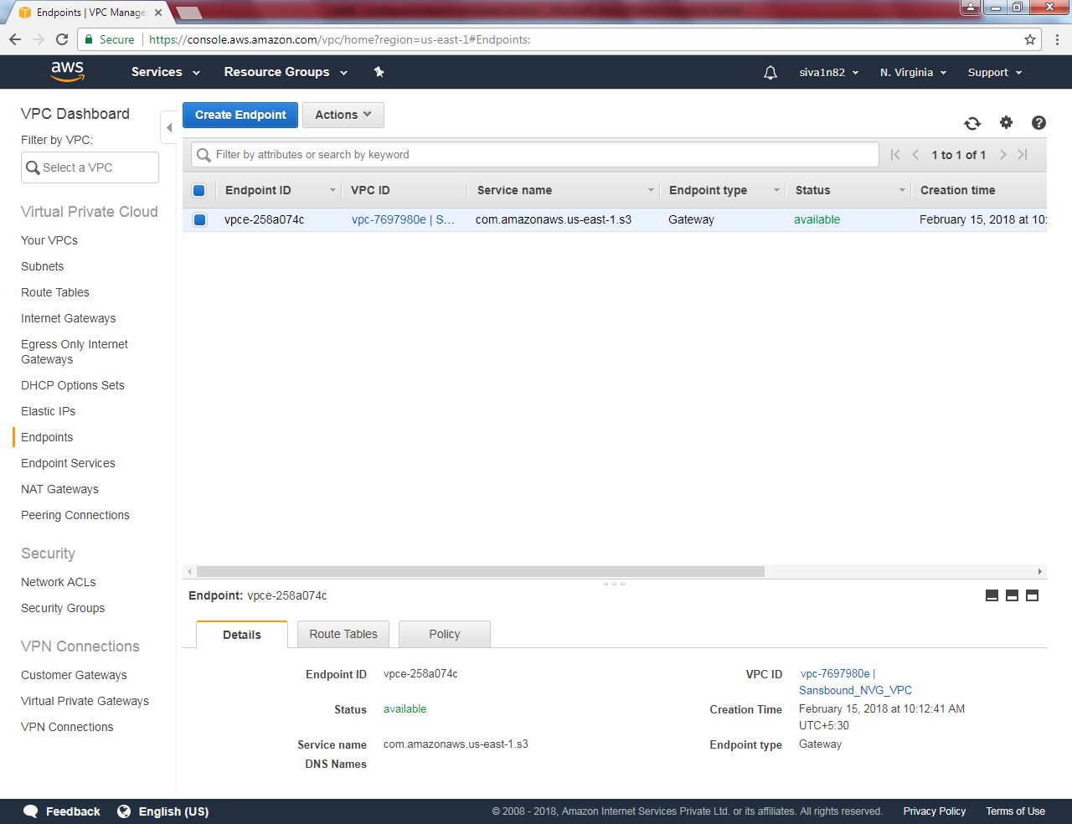

Create a new subnet in North Virginia.

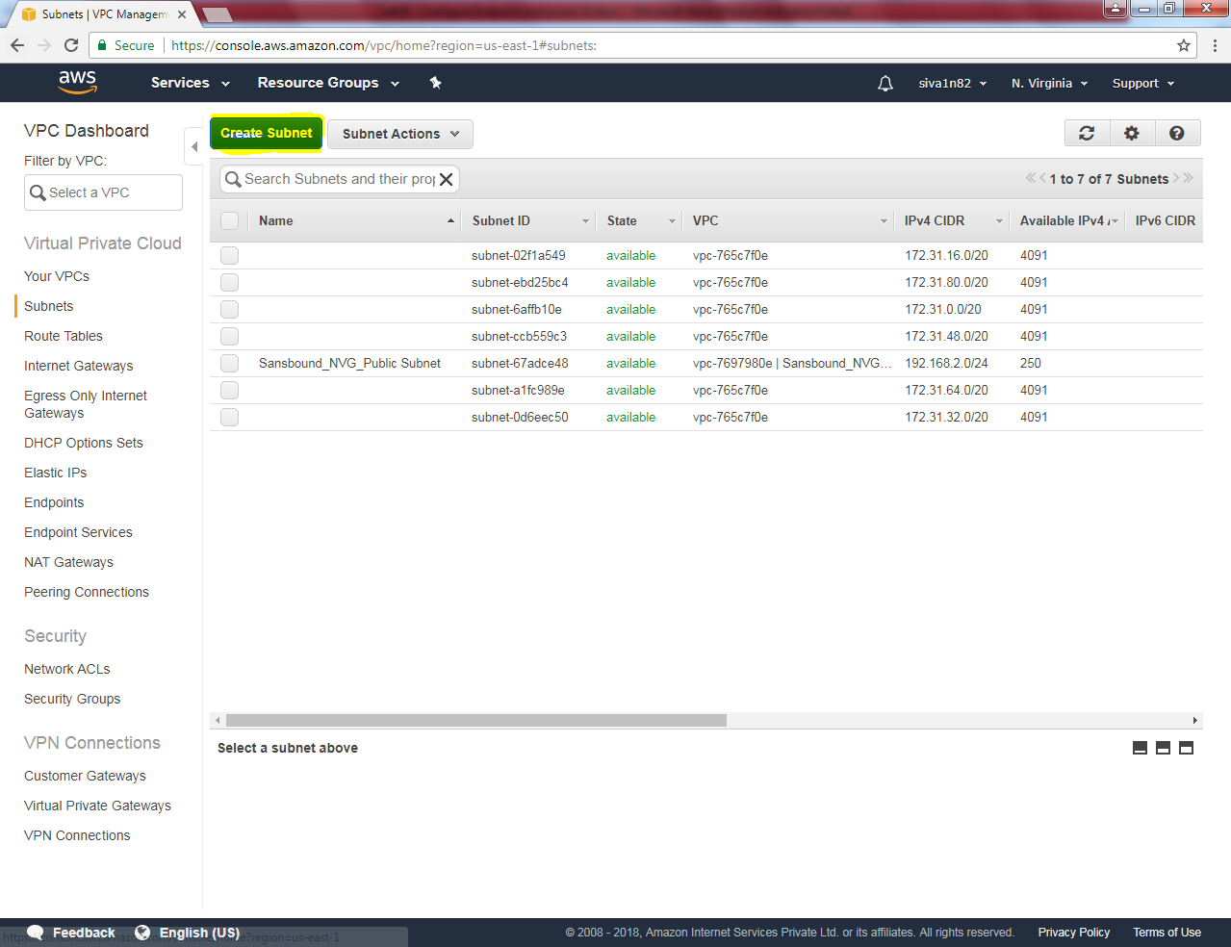

While creating subnet,

Name tag as “Sansbound_Private_Subnet_NVG”

VPC as “Sansbound_NVG_VPC”.

IPV4 CIDR Block: 192.168.1.0/24

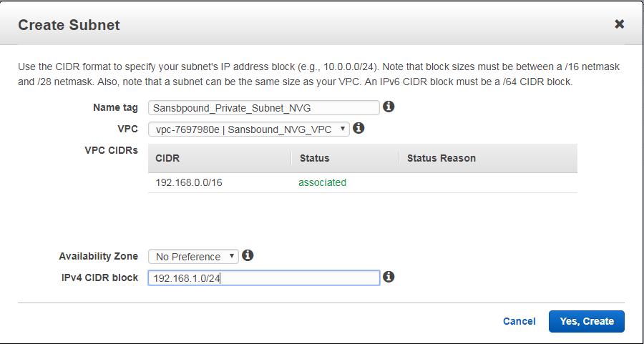

Click “Yes create”.

We can able to see s3 routing information in private routing table.

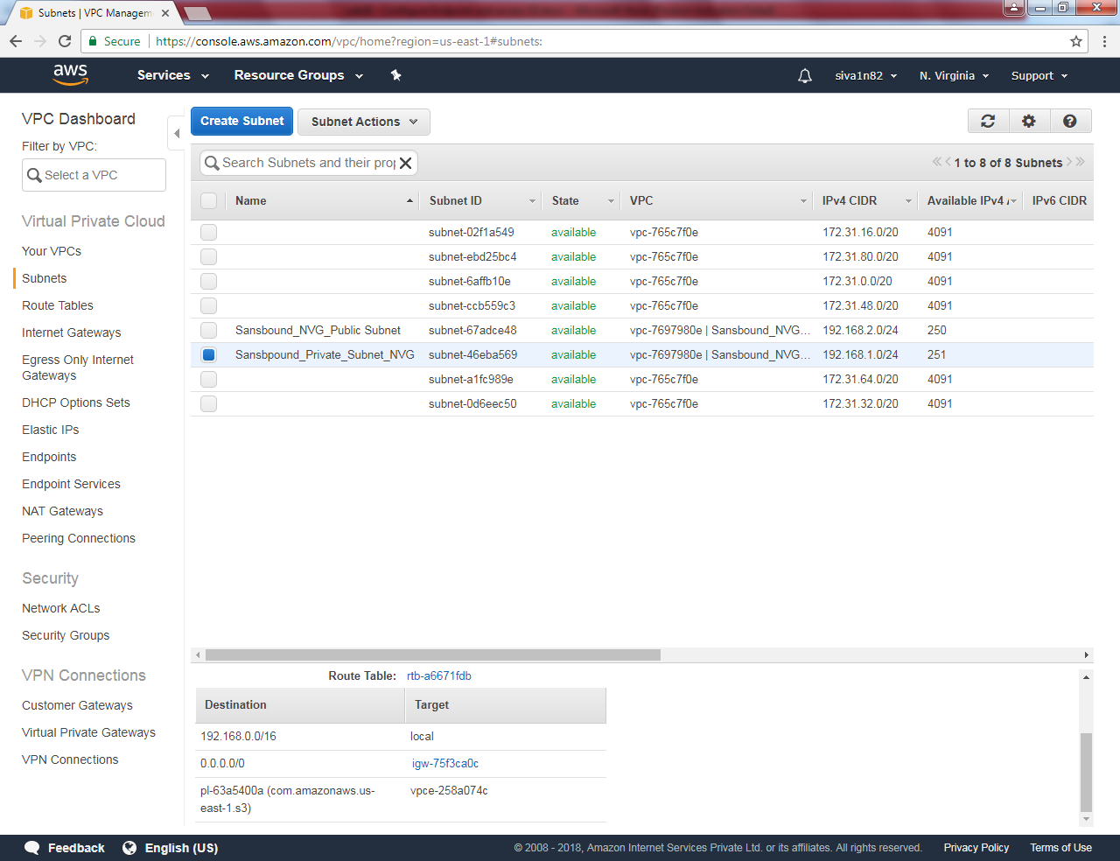

Create an windows 2016 instance by using regular steps.

Login to private instance.



Copy and paste the command line interface setup in private server. Then run the setup in private subnet server.

Try to ping google.com from private subnet, you would not able to connect.

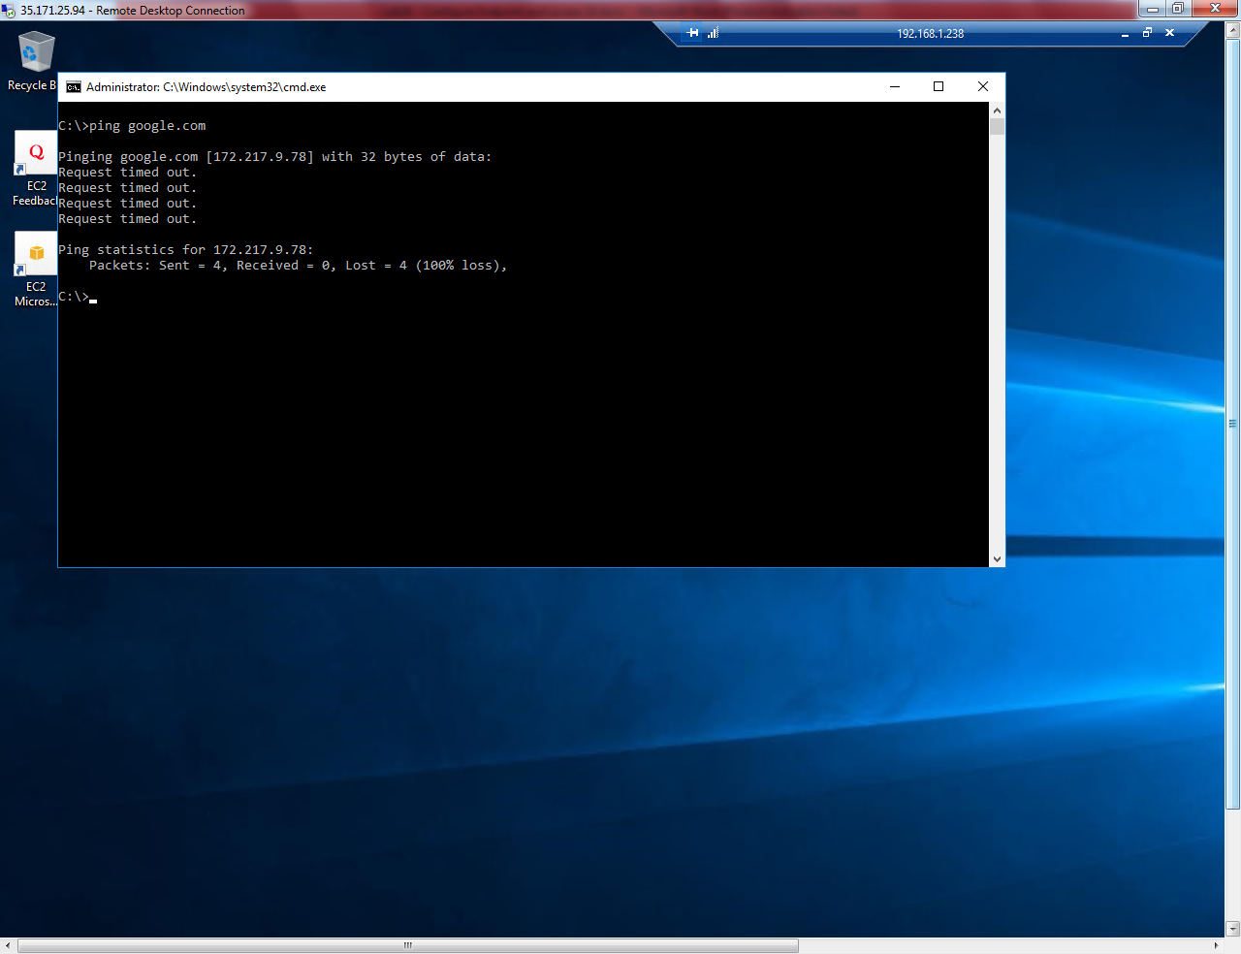

Type aws

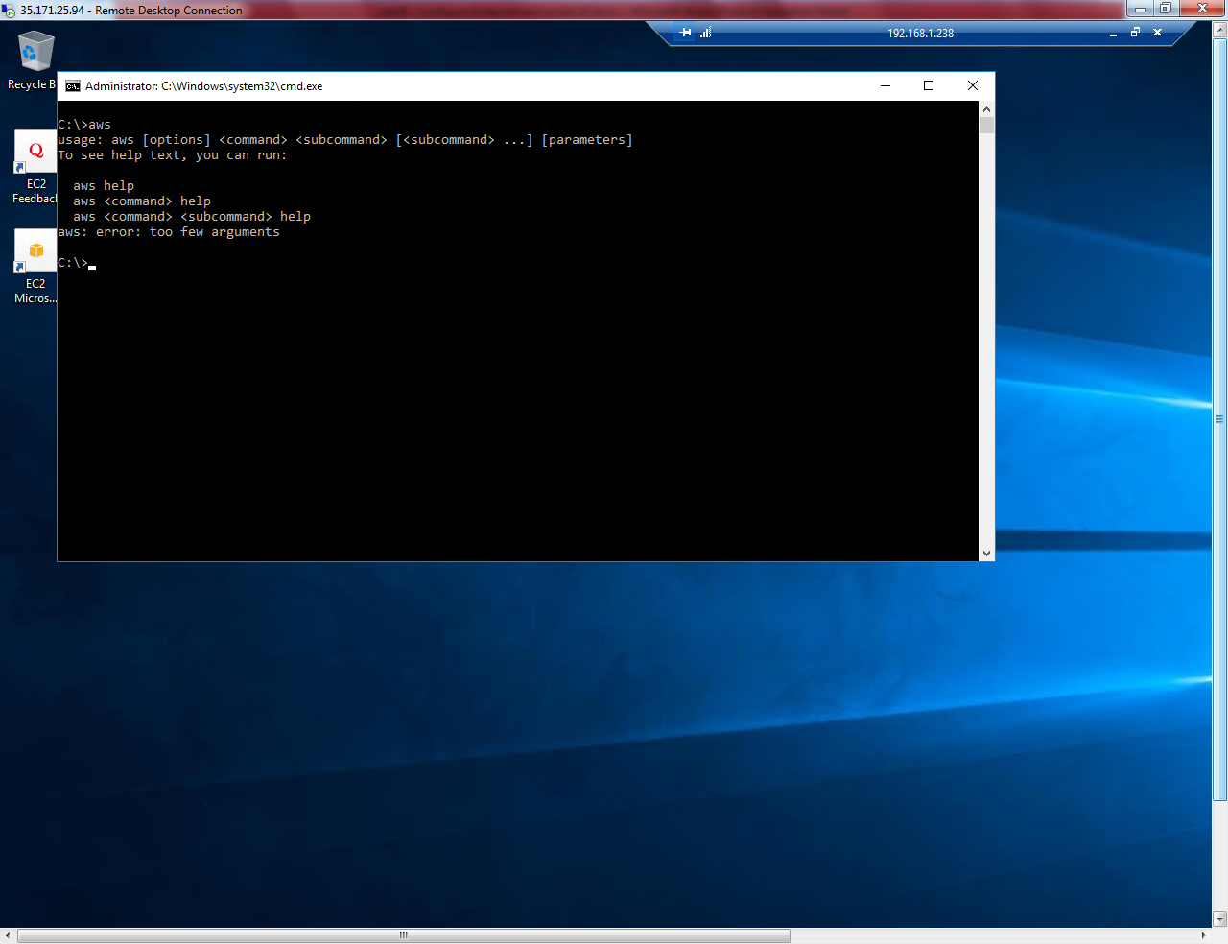

Type aws s3 ls in command prompt.

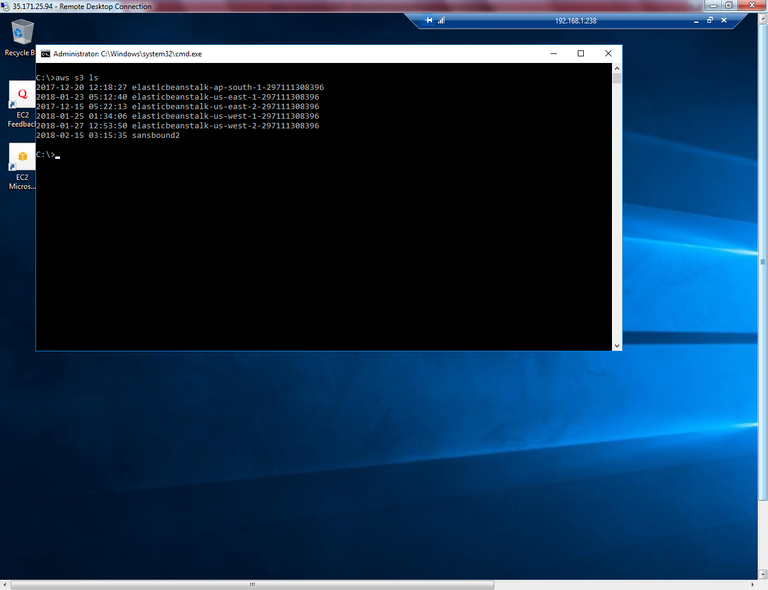

S3 can be able to access without internet.

Type aws s3 mb s3://sansbound3

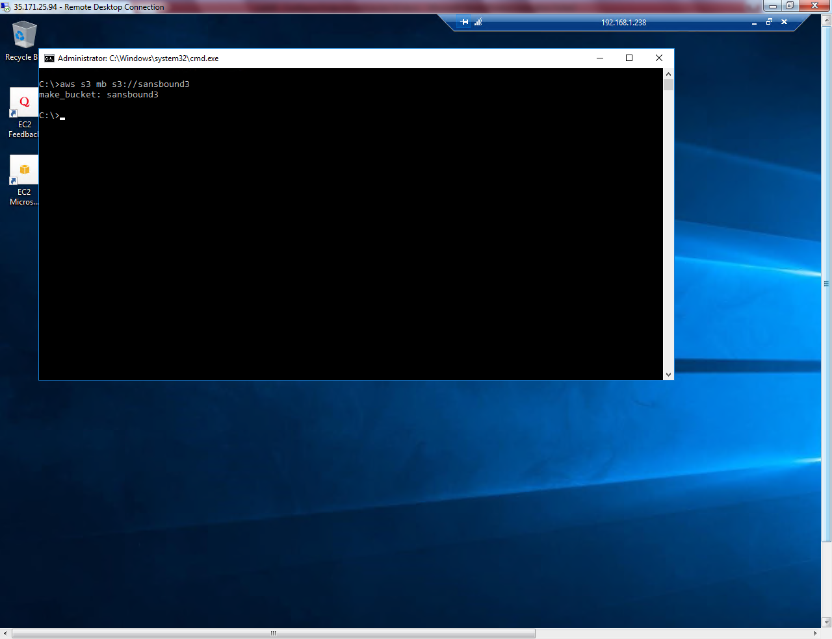

Sansbound3 bucket has been created.

Type

Aws s3 ls

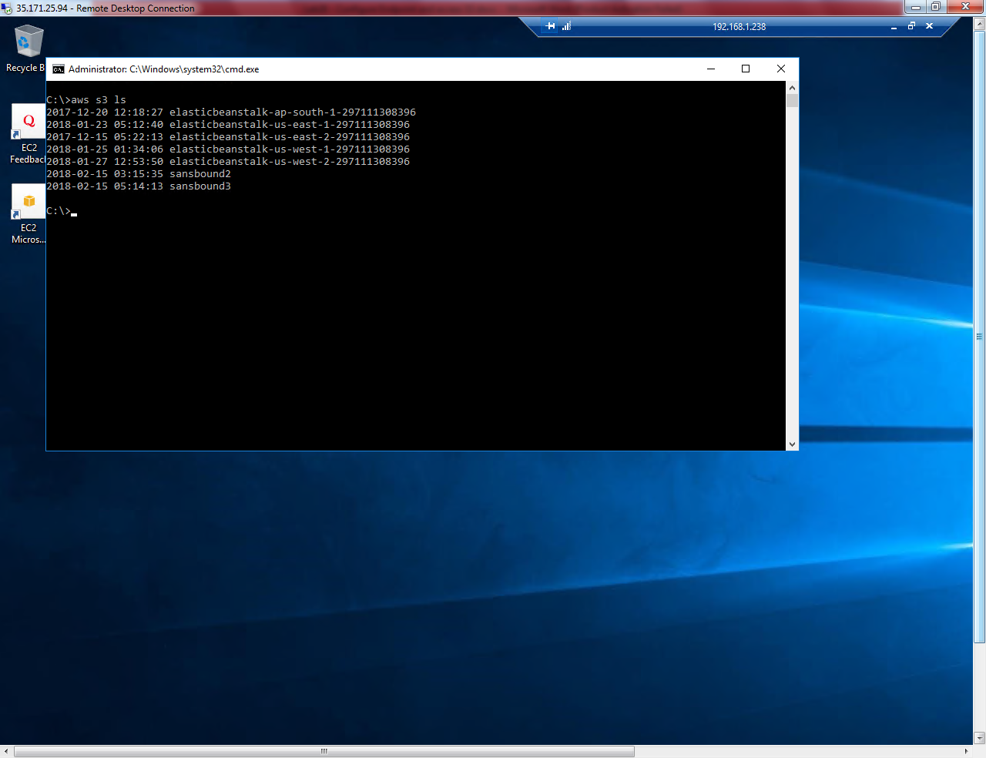

Type

Aws s3 rb s3://sansbound3

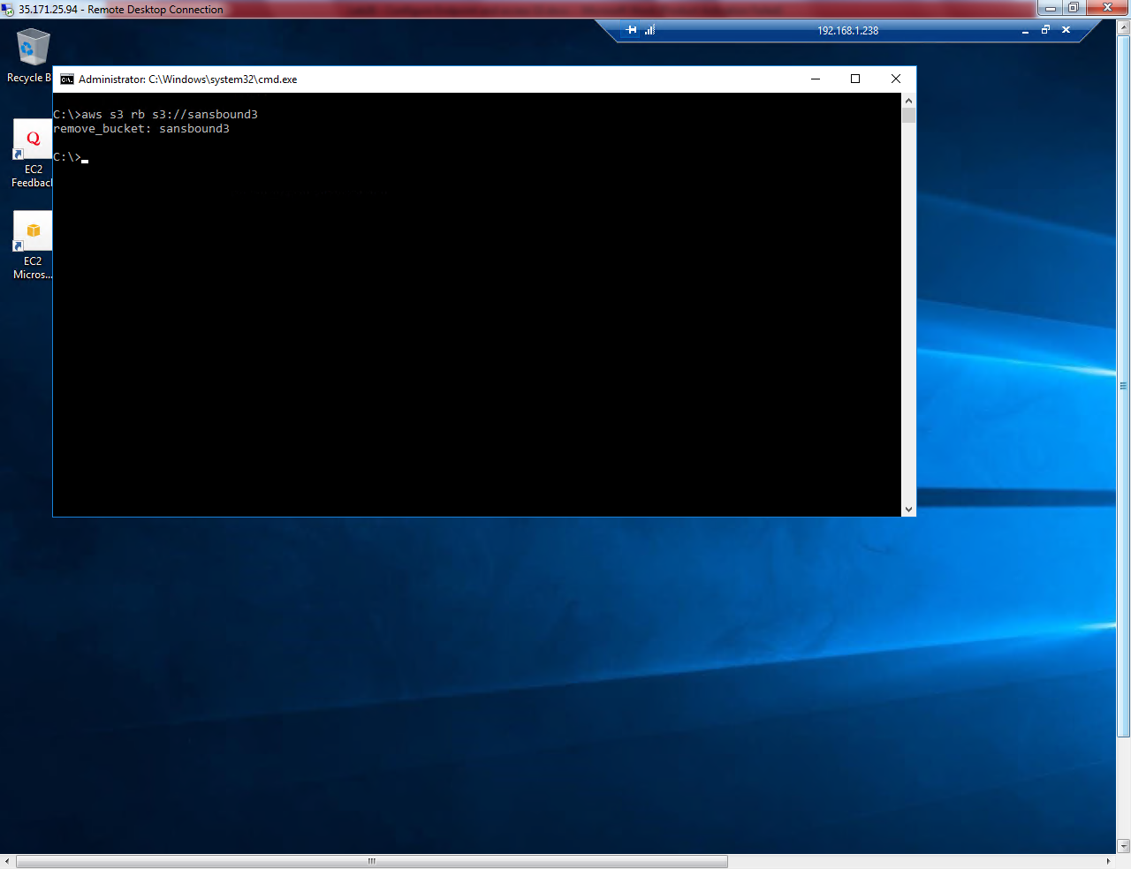

Sanbound3 bucket has been removed successfully.